|  |  |
| --- | --- |
| **Name:** | **Dhuware Chaitanya Rakesh** |
| **Roll Number:** | **20IM10009** |

**1.Aim of the experiment:**

**To study about the signal handling and frequency response of the CE amplifier**

**2.Tools used:**

**Falstad**

**3.Background knowledge (brief):**

* The most common circuit configuration for an NPN transistor is that of the Common Emitter Amplifier .

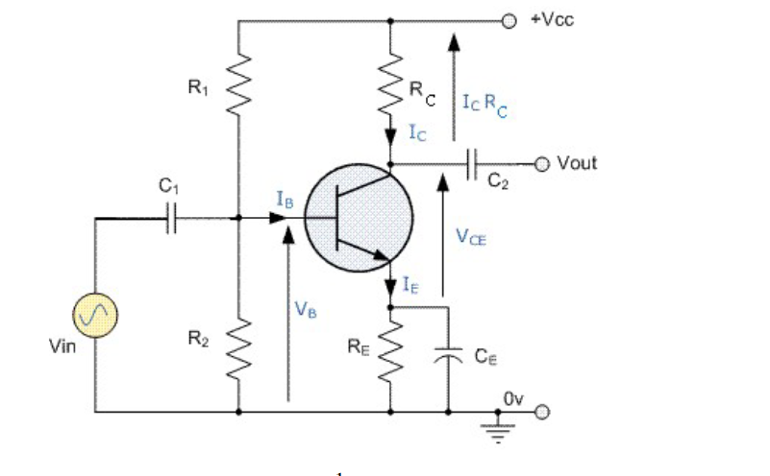

* **Load line and Q-point**   
    
  A static or DC load line can be drawn onto the output characteristics curves of the transistor to show all the possible operating points of the transistor from fully "ON" (IC = VCC/(RC + RE)) to fully "OFF" (IC = 0). The quiescent operating point or Q-point is a point on this load line which represents the values of IC and VCE that exist in the circuit   
  when no input signal is applied. Knowing VB, IC and VCE can be calculated to locate the operating point of the circuit
* In CE amplifier circuits, capacitors C1 and C2 are used as Coupling Capacitors to separate the AC signals from the DC biasing voltage. The capacitors will only pass AC signals and block any DC component. Thus they allow coupling of the AC signal into an amplifier stage without disturbing its Q point.
* The performance of an amplifier is characterized by its frequency response curve that shows output amplitude (or, more often, voltage gain) plotted versus frequency (often in log scale)

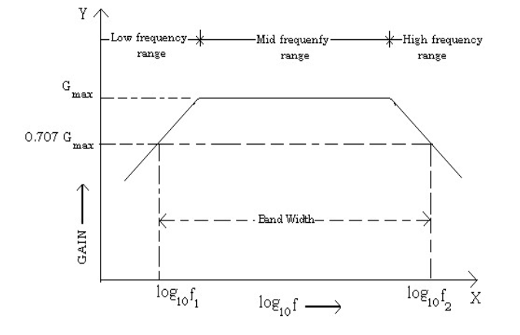

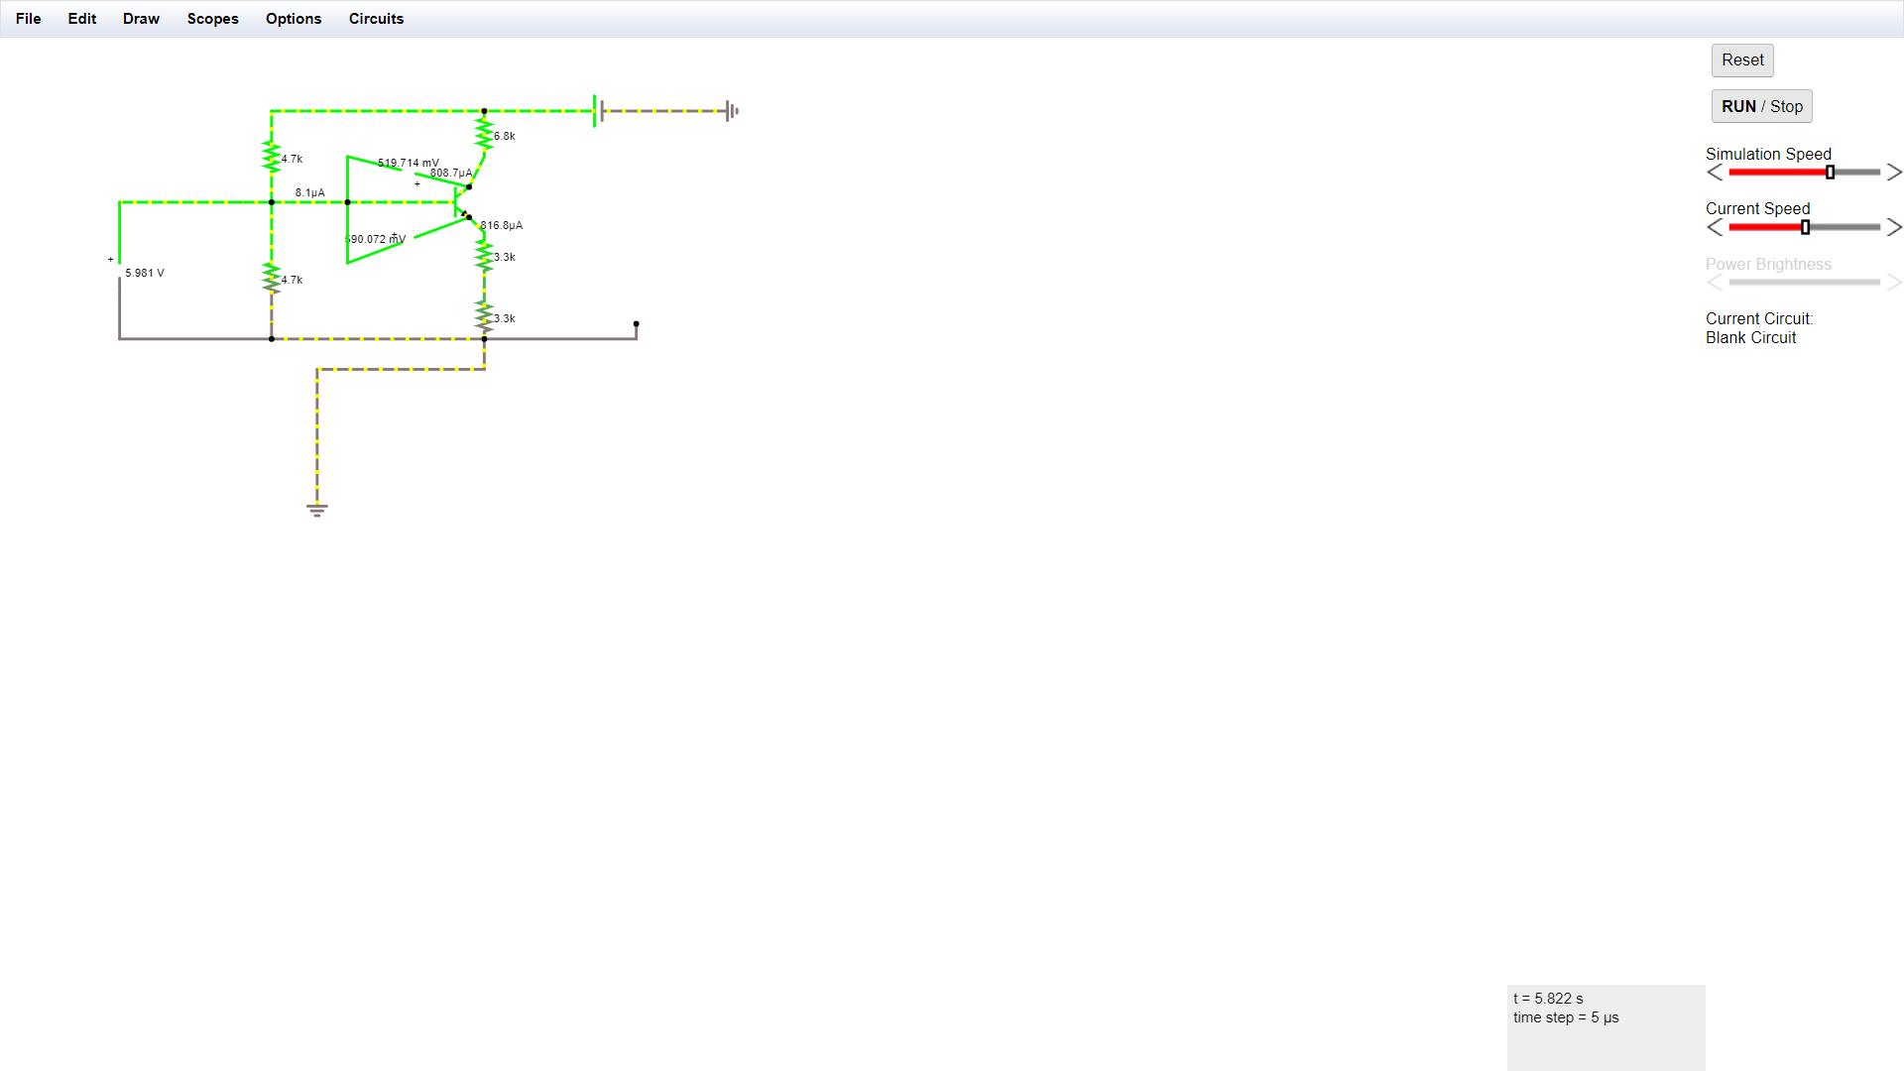**4.Circuit (hand drawn/image)**

DC Conditions

Signal Handling and Frequency Response

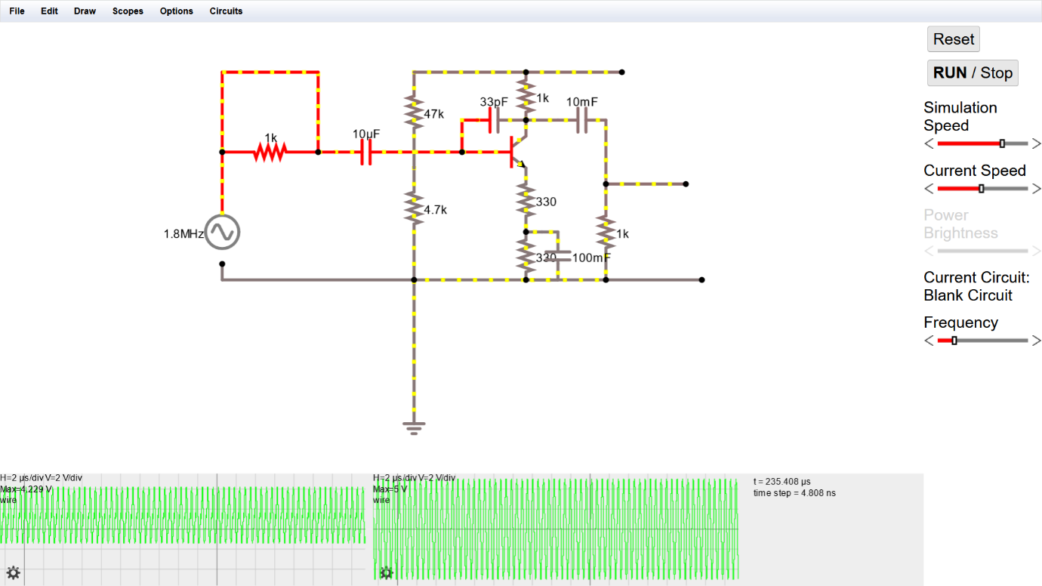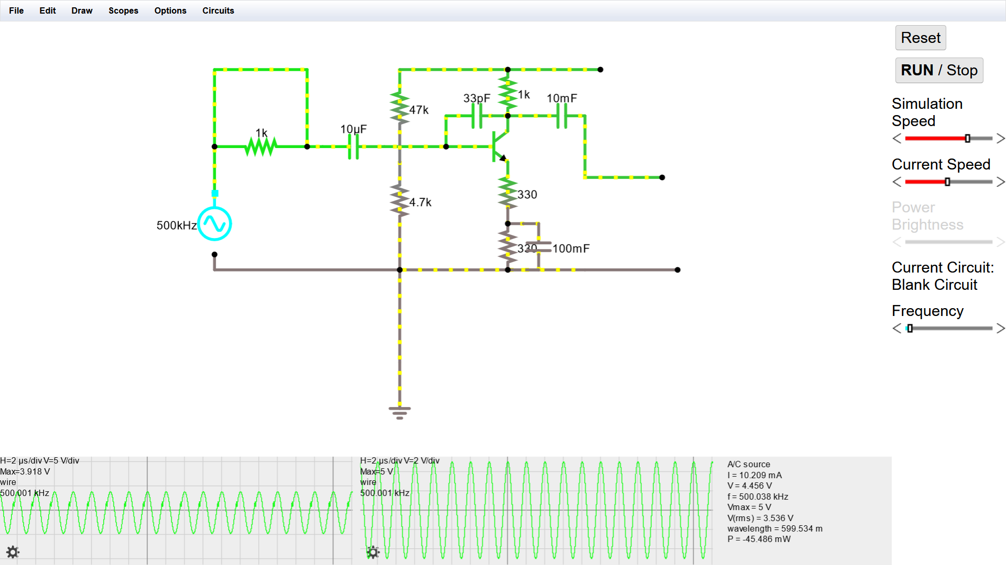

**5.Measurement Data (Tabular form)**

**Signal Handling with RL Disconnected (f=4khz) Signal Handling with RL connected**

**(f=4khz RL= 1k ohms)**

|  |  |  |
| --- | --- | --- |
| Vin (mV) | Vout(V) | Gain = Vin/Vout |
| 100 | 1.9 | 19 |
| 120 | 2.3 | 19.16666667 |
| 130 | 2.5 | 19.23076923 |
| 140 | 2.7 | 19.28571429 |
| 150 | 2.85 | 19 |
| 160 | 3.05 | 19.0625 |
| 170 | 3.4 | 20 |
| 180 | 3.5 | 19.44444444 |
| 190 | 3.55 | 18.68421053 |
| 200 | 3.8 | 19 |
| 250 | 5.3 | 21.2 |
| 300 | 5.8 | 19.33333333 |
| 350 | 6.8 | 19.42857143 |
| 400 | 7.7 | 19.25 |
| 500 | 9.4 | 18.8 |
| **580** | **10.8** | **18.62068966** |
| 600 | 10.82 | 18.03333333 |
| 700 | 11.2 | 16 |
| 800 | 11.2 | 14 |

|  |  |  |
| --- | --- | --- |
| Vin (mV) | Vout(V) | Gain = Vin/Vout |
| 450 | 1.18 | 2.622222 |
| 500 | 1.25 | 2.5 |
| 600 | 1.5 | 2.5 |
| **620** | **1.52** | **2.451613** |
| 700 | 1.6 | 2.285714 |
| 800 | 1.71 | 2.1375 |

**Frequency Response with RL connected Frequency Response with RL**

**disconnected**

|  |  |  |
| --- | --- | --- |
| f(in kHz) | Vout (V) | 20log(Vin/Vout) |
| 300 | 0.41 | 8.173277481 |
| 400 | 0.4 | 7.958800173 |
| 500 | 0.38 | 7.513272279 |
| 800 | 0.36 | 7.043650362 |
| 1000 | 0.34 | 6.547178688 |
| 1200 | 0.32 | 6.020599913 |
| 1500 | 0.29 | 5.165560305 |
| 2000 | 0.25 | 3.87640052 |
| 2500 | 0.211 | 2.403249453 |
| 3000 | 0.18 | 1.023050449 |
| 3236 | 0.17 | 0.526578774 |

|  |  |  |
| --- | --- | --- |
| f(in Hz) | Vout | 20log(Vin/Vout) |
| 100 | 3.3 | 26.28788 |
| 20000 | 3.2 | 26.0206 |
| 50000 | 3.1 | 25.74483 |
| 100000 | 2.9 | 25.16556 |
| 200000 | 2.3 | 23.15216 |
| 300000 | 1.85 | 21.26103 |
| 400000 | 1.5 | 19.43943 |
| 500000 | 1.24 | 17.78603 |
| 800000 | 0.79 | 13.87014 |
| 1000000 | 0.65 | 12.17587 |
| 1200000 | 0.57 | 11.0351 |
| 1500000 | 0.46 | 9.172757 |
| 2000000 | 0.35 | 6.798961 |
| 2500000 | 0.275 | 4.704254 |
| 3000000 | 0.225 | 2.961251 |
| 3236000 | 0.21 | 2.361986 |

**6.Graph (Image)/Screenshots**

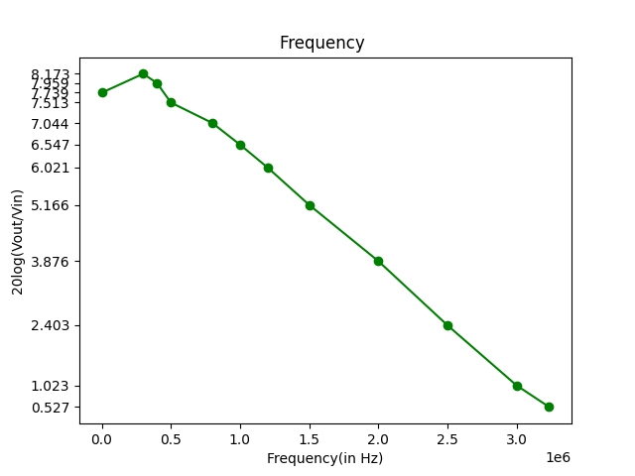

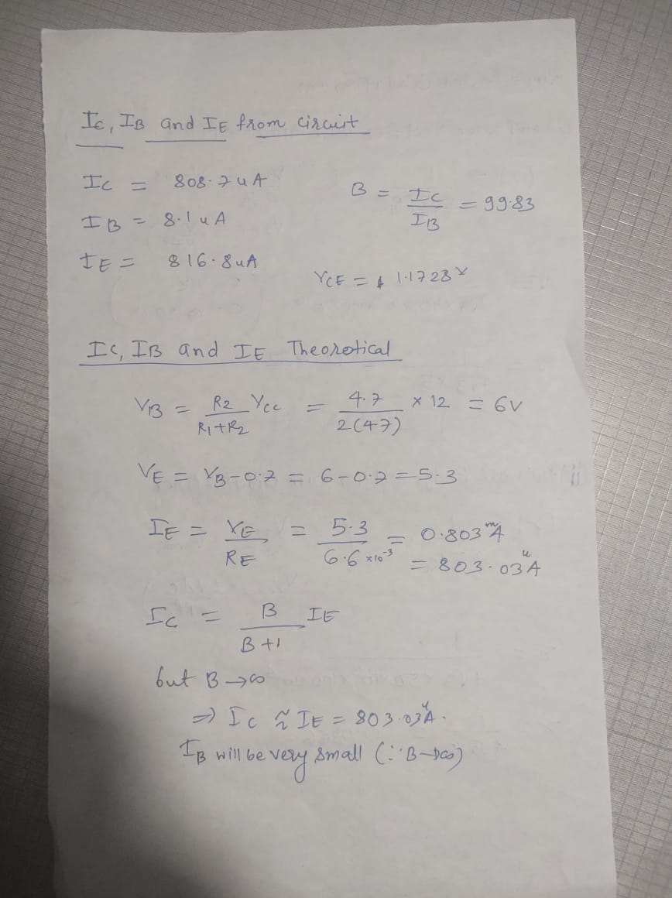**7.Conclusion**

From signal handling experiment we get

Vsm = 0.58 V Load resistance disconnected

0.62 V Load resistance connected

From frequency response

Without load resistance: fl = -

fh = 1500 KHz

Without load resistance: fl = -

fh = 190 kHz

**8.Discussions**

.

* **The common emitter amplifier is a three basic single-stage BJT and is used as a voltage amplifier. The input of this amplifier is taken from the base terminal, the output is collected from the collector terminal and the emitter terminal is common for both the terminals**
* **When a signal is applied across the emitter-base junction, the forward bias across this junction increases during the upper half cycle. This leads to an increase in the flow of electrons from the emitter to a collector through the base, hence increases the collector current. The increasing collector current makes more voltage drops across the collector load resistor RC.**
* **The current gain of the common emitter amplifier is defined as the ratio of change in collector current to the change in base current. The voltage gain is defined as the product of the current gain and the ratio of the output resistance of the collector to the input resistance of the base circuits. The following equations show the mathematical expression of the voltage gain and the current gain.**

**β = ΔIc/ ΔIb**

**Av = β Rc/Rb**

* **From the above graph of frequency response, we observe that the voltage gain drops off at low (< FL) and high (> FH) frequencies, whereas it is constant over the mid-frequency range (FL to FH).**
* **The capacitor used at input and output act as coupling capacitor and DC blocking capacitors. They provide very low impedance to ac signal. This results in coupling of ac signal without producing any disturbances in DC signal.**
* **In active region the amplifier is biased as Vcc > Vce.**